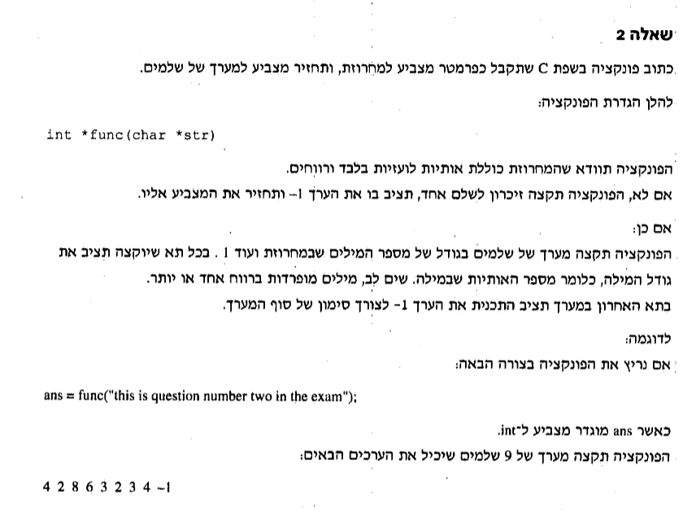

int *func(char *str)

{

int size = 0,cnt=0;

int i,j=0;

for ( i = 0; i < strlen(str); i++)

{

if ((str[i] >= 'a'&&str[i] <= 'z') || (str[i] >= 'A'&&str[i] <= 'Z') || str[i] == ' ')//check if letter or space

{

if (str[i] == ' ')

size++;//counts how many words in the string

}

else

{

int *not;//if there is a char that is not a letter or space create int

*not = -1;// integer equals to -1

return not;//return it

}

}

size += 2;//add the last word and one more slot

int *arr= (int*)malloc(sizeof(int)*size);//הקצאה דינאמית בגודל size

for (i = 0; i < strlen(str); i++)

{

if (str[i] != ' ')

cnt++;//counts the letters in each word

else

{

arr[j] = cnt;//insert the number of letters into the array

j++;

cnt = 0;

}

}

arr[j] = cnt;

j++;

arr[j] = -1;

}

void main()

{

char str[255];

printf("please enter a sentence: ");

gets_s(str);

func(str);

}